Your Abstract's Title Starts Here: Please Center
use Arial 14 pt
FULL First Author^{1, a}, FULL Second Author^{2,b} and Others^{3,c}
¹Full address of first author, including country
²Full address of second author, including country
³List all distinct addresses in the same way
ªemail, ^{b}email, ^{c}email

Abstract.
Abstracts have to be written in English, not more than two formatted pages, submitted until 30.03.2015. Use this file for MS Word (with help of the formatting styles) as a template of your contribution. Please use Arial font through the whole text, for line spacing use multiple 1,15.

Keywords: keyword1, keyword2, …

Introduction
Author(s) name(s) should be without titles. Should authors use tables or figures from other Publications, they must ask the corresponding publishers to grant them the right to publish this material in their paper.
Use italic for emphasizing a word or phrase. Do not use boldface typing or capital letters except for section headings (cf. remarks on section headings, below).

Organization of the Text
The section headings are in boldface capital and lowercase letters.
Page Numbers. Do not use page numbers.
Tables (refer with: Table 1, Table 2, ...) should be presented as part of the text, but in such a way as to avoid confusion with the text. The caption should be self-contained and placed below the table. Units in tables should be given in square brackets [meV]. If square brackets are not available, use curly {meV} or standard brackets (meV).
Special signs, for example , α γ μ Ω () ≥ ± ● Γ {110} should always be written in with the fonts Arial.
Equations (refer with: Eq. 1, Eq. 2, ...) should be indented 5 mm. There should be one line of space above the equation and one line of space below it before the text continues. The equations have to be numbered sequentially, and the number put in parentheses at the right-hand edge of the text. Equations should be punctuated as if they were an ordinary part of the text. Punctuation appears after the equation but before the equation number, e.g.:

c² = a² + b². (1)

Figures (refer with: Fig. 1, Fig. 2, ...) also should be presented as part of the text, leaving enough space so that the caption will not be confused with the text. The caption should be self-contained and placed below the figure. There should be one line of space above the figures and one line of space below it before the text continues. For best quality the pictures should have a resolution of 300 dpi(dots per inch).
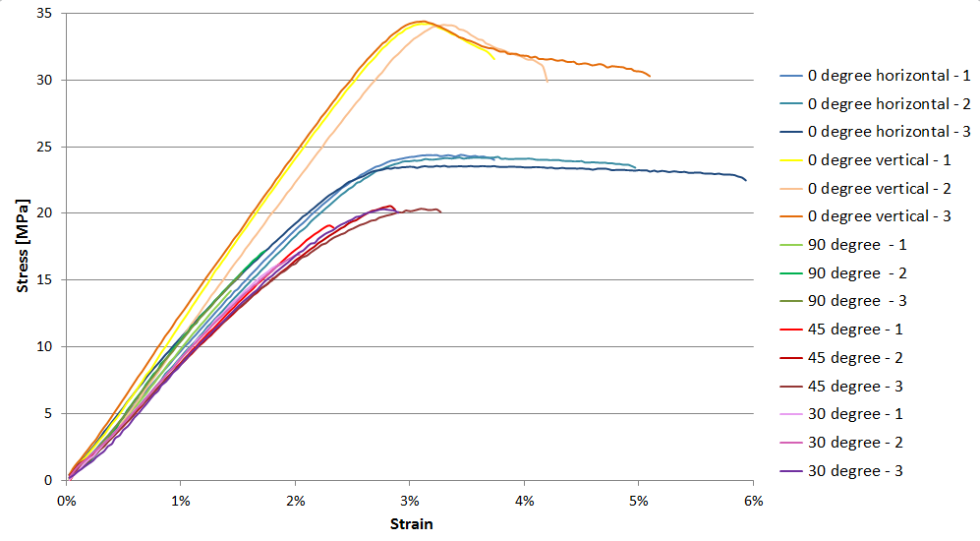
Fig. 1 Stress-strain curves (Arial 10 pt, centered text)

Literature References
References are cited in the text just by square brackets [1]. (If square brackets are not available, slashes may be used instead, e.g. /2/.) Two or more references at a time may be put in one set of brackets [3,4]. The references are to be numbered in the order in which they are cited in the text and are to be listed at the end of the contribution under a heading References, see our example below.

Summary
All accepted abstracts will only be published in the conference proceedings in a digital version.

References
- A. Author, B. Author: Title. Journal of Xyz, Vol. 1 (2014) pp. 08-15.
- Information on http://ysesm2015.jku.at (without hyperlink)

